Southern Alberta institute of Technology

Title: Create Users, Roles & Profiles

by

**Femi Adams**

Winter 2023

**Dba User Creation**

SQL> create user tea_owner identified by tea_owner;

SQL> grant dba to tea_owner;

SQL> connect tea_owner/tea_owner

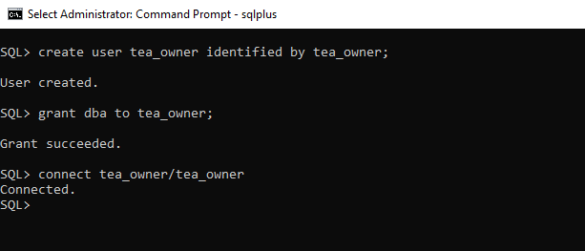

SQL> show user

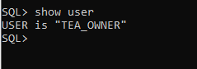

**Create Role Scripts**

**Senior Agent Role**

**Script to show roles and privileges (select role, table_name, privilege from role_tab_privs;)**

Senior agent has privilege on all tables. He can view and insert on employee table. One senior agent (commission specialist) has all privilege on commission table

SQL> create role senior_agent;

SQL> grant connect to senior_agent;

SQL> grant create session to senior_agent;

SQL> grant all on booking to senior_agent;

SQL> grant all on class to senior_agent;

SQL> grant all on commission to senior_agent;

SQL> grant all on company to senior_agent;

SQL> grant all on customer to senior_agent;

SQL> grant all on cust_credit_card to senior_agent;

SQL> grant all on department to senior_agent;

SQL> grant all on destination to senior_agent;

SQL> grant select, insert on employee to senior_agent;

SQL> grant all on itinerary to senior_agent;

SQL> grant all on main_supplier to senior_agent;

SQL> grant all on payment to senior_agent;

SQL> grant all on payment_type to senior_agent;

SQL> grant all on product to senior_agent;

SQL> grant all on sale to senior_agent;

SQL> grant all on supplier to senior_agent;

SQL> grant all on tax_quote to senior_agent;

SQL> select role, table_name, privilege from role_tab_privs where role = 'SENIOR_AGENT';

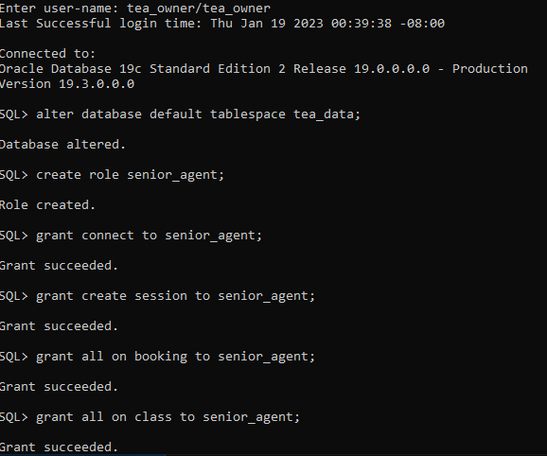

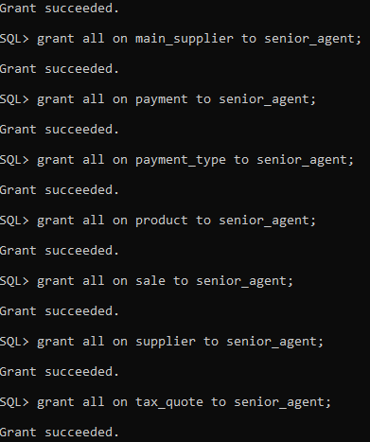

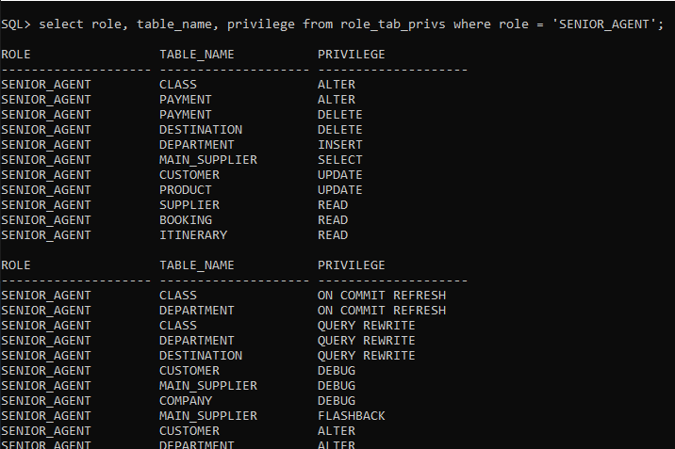

**Commission Specialist**

Has same authorization with senior agents but has all access on commission table

SQL> create role commission_specialist;

SQL> grant senior_agent to commission_specialist;

SQL> grant all on commission to commission_specialist;



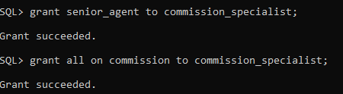

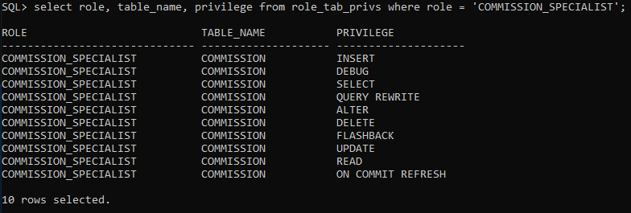

**Intermediate Agent Role**

Intermediate agent has all access to most tables. He can only view, employee, commission, department.

SQL> create role intermediate_agent;

SQL> grant connect to intermediate_agent;

SQL> grant create session to intermediate_agent;

SQL> grant all on booking to intermediate_agent;

SQL> grant all on class to intermediate_agent;

SQL> grant select, insert on commission to intermediate_agent;

SQL> grant all on cust_credit_card to intermediate_agent;

SQL> grant select on department to intermediate_agent;

SQL> grant all on destination to intermediate_agent;

SQL> grant select on employee to intermediate_agent;

SQL> grant all on itinerary to intermediate_agent;

SQL> grant all on main_supplier to intermediate_agent;

SQL> grant all on payment to intermediate_agent;

SQL> grant all on payment_type to intermediate_agent;

SQL> grant all on product to intermediate_agent;

SQL> grant all on sale to intermediate_agent;

SQL> grant all on supplier to intermediate_agent;

SQL> grant select, insert on tax_quote to intermediate_agent;

SQL> select role, table_name, privilege from role_tab_privs where role = 'INTERMEDIATE_AGENT';

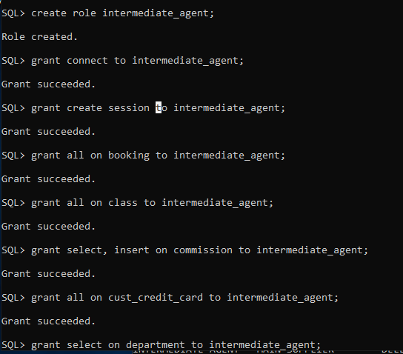

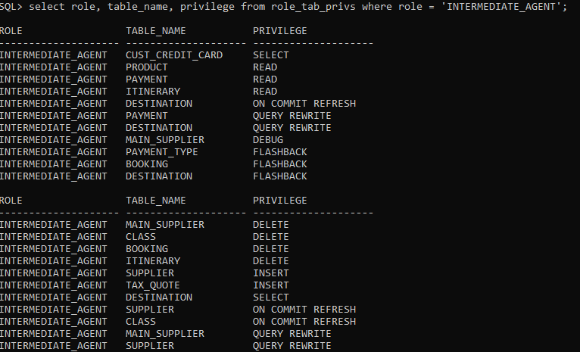

**Junior Agent Role**

Junior Agents can only view and insert on some tables and don’t have access to most tables.

SQL> create role junior_agent;

SQL> grant create session to junior_agent;

SQL> grant select, insert on booking to junior_agent;

SQL> grant select, insert on class to junior_agent;

SQL> grant select on company to junior_agent;

SQL> grant select, insert on cust_credit_card to junior_agent;

SQL> grant select, insert on itinerary to junior_agent;

SQL> grant select on main_supplier to junior_agent;

SQL> grant select, insert on payment to junior_agent;

SQL> grant select on product to junior_agent;

SQL> grant select, insert on sale to junior_agent;

SQL> grant select on supplier to junior_agent;

SQL> grant select on tax_quote to junior_agent;

SQL> select role, table_name, privilege from role_tab_privs where role = 'INTERMEDIATE_AGENT';

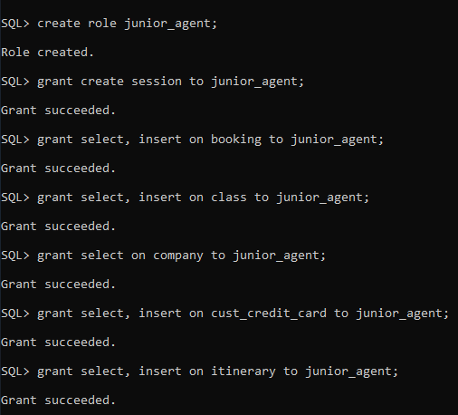

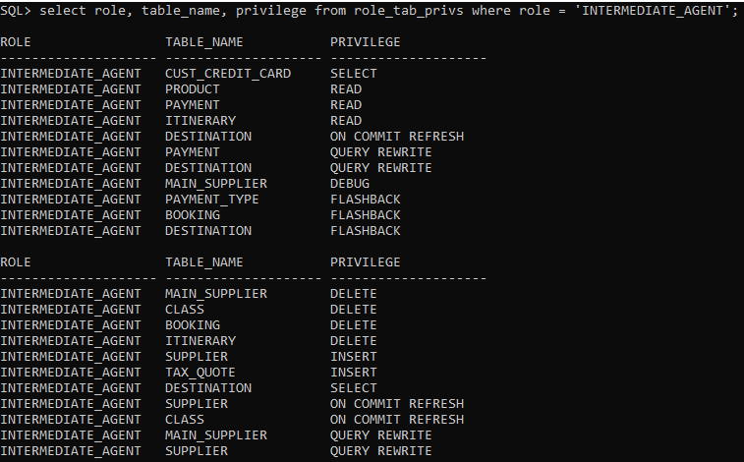

**TEA MANAGER ROLE**

Has access to all tables, can create tables, can create views, can back up tables, can create users, can flashback any table, lock any table etc.

SQL> create role manager;

SQL> grant connect, resource to manager;

SQL> grant create user to manager;

SQL> grant alter user to manager;

SQL> grant create view to manager;

SQL> grant create table to manager;

SQL> grant create any table to manager;

SQL> grant drop any table to manager;

SQL> grant insert any table to manager;

SQL> grant flashback any table to manager;

SQL> grant alter any table to manager;

SQL> grant lock any table to manager;

SQL> grant backup any table to manager;

SQL> grant create any directory to manager;

SQL> grant drop any directory to manager;

SQL> grant create profile to manager;

SQL> grant alter profile to manager;

SQL> grant drop profile to manager;

SQL> grant create role to manager;

SQL> grant alter any role to manager;

SQL> grant create any table to manager;

SQL> grant alter any table to manager;

SQL> grant drop any table to manager;

SQL> grant insert any table to manager;

SQL> grant select any table to manager;

SQL> grant update any table to manager;

SQL> grant delete any table to manager;

SQL> grant all on booking to manager;

SQL> grant all on class to manager;

SQL> grant all on commission to manager;

SQL> grant all on company to manager;

SQL> grant all on customer to manager;

SQL> grant all on cust_credit_card to manager;

SQL> grant all on department to manager;

SQL> grant all on destination to manager;

SQL> grant all on employee to manager;

SQL> grant all on itinerary to manager;

SQL> grant all on main_supplier to manager;

SQL> grant all on payment to manager;

SQL> grant all on payment_type to manager;

SQL> grant all on product to manager;

SQL> grant all on sale to manager;

SQL> grant all on supplier to manager;

SQL> grant all on tax_quote to manager;

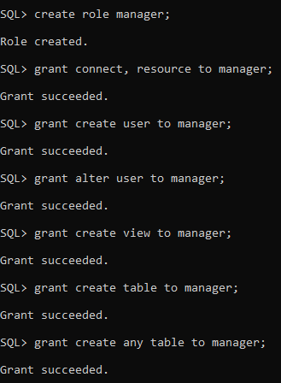

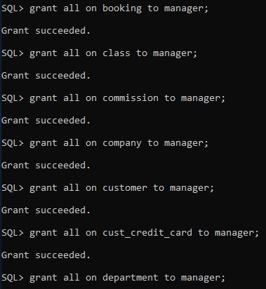

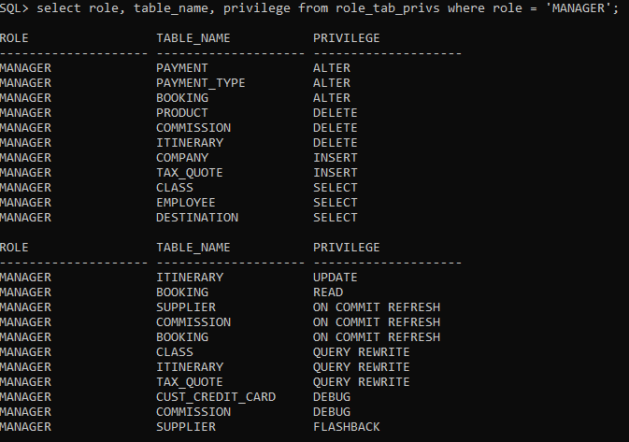

**Owner Role**

Has access to everything in the database

SQL> create role owner;

SQL> grant dba to owner;

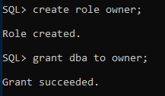

SQL> SELECT * FROM session_privs order by privilege;

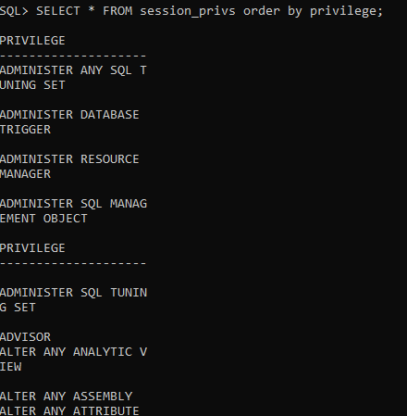

**User Creation & Grant Roles**

**Users**

SQL> create user aleshia identified by aleshia;

SQL> create user evan identified by evan;

SQL> create user france identified by france;

SQL> create user ulysses identified by ulysses;

SQL> create user Tyisha identified by Tyisha;

SQL> create user eric identified by eric;

SQL> create user marg identified by marg;

SQL> create user laquita identified by laquita;

SQL> create user laura identified by laura;

SQL> create user yuette identified by yuette;

SQL> create user fernanda identified by fernanda;

SQL> create user charlesetta identified by charlesetta;

SQL> create user corrinne identified by corrinne;

SQL> create user niesha identified by niesha;

SQL> create user charisse identified by charisse;

SQL> create user reuben identified by reuben;

SQL> create user michell identified by michell;

SQL> create user edgar identified by edgar;

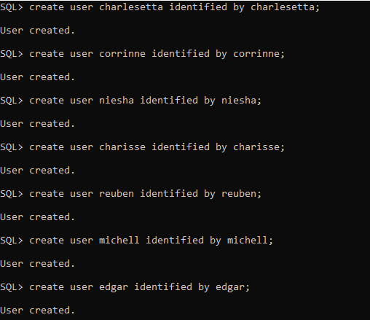

SQL> select username, account_status, default_tablespace from dba_users;

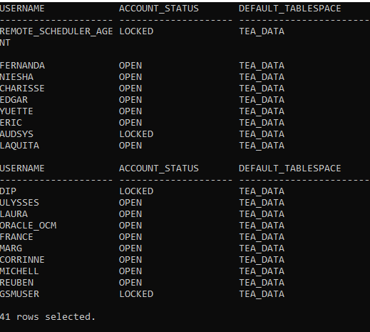

**Grant Role to Users**

**Junior agent to users**

SQL> grant junior_agent to aleshia;

SQL> grant junior_agent to evan;

SQL> grant junior_agent to france;

SQL> grant junior_agent to ulysses;

SQL> grant junior_agent to tyisha;

SQL> grant junior_agent to eric;

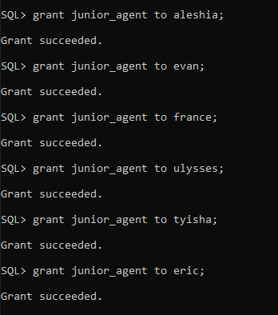

**Intermediate agent to users**

SQL> grant intermediate_agent to marg;

SQL> grant intermediate_agent to laquita;

SQL> grant intermediate_agent to laura;

SQL> grant intermediate_agent to yuette;

SQL> grant intermediate_agent to fernanda;

SQL> grant intermediate_agent to charlesetta;

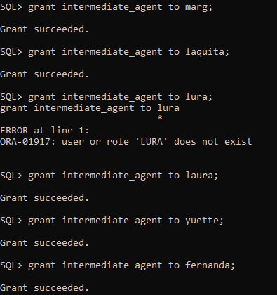

**Senior agent to users**

SQL> grant senior_agent to corrinne;

SQL> grant senior_agent to niesha;

SQL> grant senior_agent to charisse;

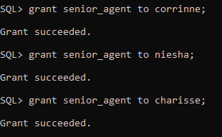

**Commission Specialist to user**

SQL> grant commission_specialist to reuben;

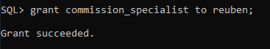

**Manager to user**

SQL> grant manager to michell;

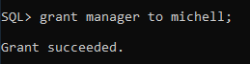

**Owner to user**

SQL> grant owner to edgar;

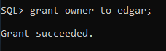

**Profile Creation**

SQL> create profile junior_time_limit limit connect_time unlimited sessions_per_user 6 idle_time 15 password_lock_time 3 failed_login_attempts 3;

SQL> create profile intermediate_time_limit limit connect_time unlimited sessions_per_user 6 idle_time 15 password_lock_time 3 failed_login_attempts 3;

SQL> create profile senior_time_limit limit connect_time unlimited sessions_per_user 4 idle_time 15 password_lock_time 3 failed_login_attempts 3;

SQL> create profile manager_time_limit limit connect_time unlimited sessions_per_user 1 idle_time unlimited password_lock_time unlimited failed_login_attempts unlimited;

SQL> create profile owner_time_limit limit connect_time unlimited sessions_per_user 1 idle_time unlimited password_lock_time unlimited failed_login_attempts unlimited;

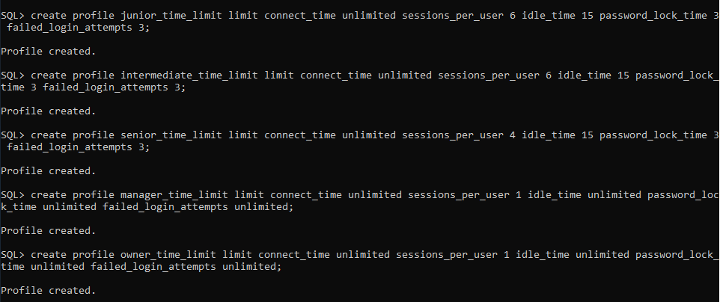

SQL> show parameter resource_limit;

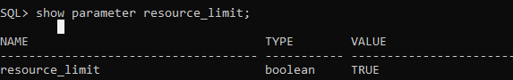

**Assign profile to users**

**Junior profile**

Junior time limit is assigned to junior agents

SQL> alter user aleshia profile junior_time_limit;

SQL> alter user evan profile junior_time_limit;

SQL> alter user france profile junior_time_limit;

SQL> alter user ulysses profile junior_time_limit;

SQL> alter user tyisha profile junior_time_limit;

SQL> alter user eric profile junior_time_limit;

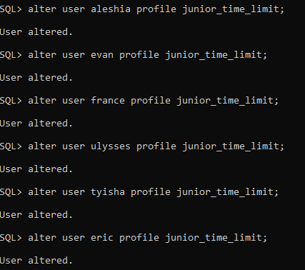

**Intermediate profile**

Profile assigned to intermediate agents

SQL> alter user marg profile intermediate_time_limit;

SQL> alter user laquita profile intermediate_time_limit;

SQL> alter user laura profile intermediate_time_limit;

SQL> alter user yuette profile intermediate_time_limit;

SQL> alter user fernanda profile intermediate_time_limit;

SQL> alter user charlesetta profile intermediate_time_limit;

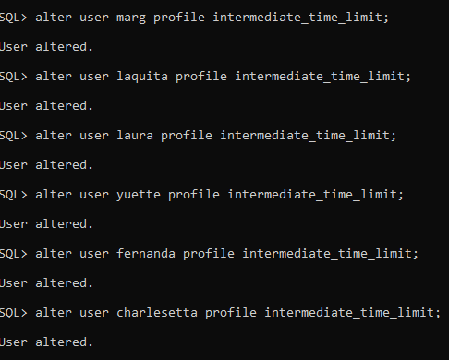

**Senior profile**

Profile assigned to senior agents

SQL> alter user corrinne profile senior_time_limit;

SQL> alter user niesha profile senior_time_limit;

SQL> alter user charisse profile senior_time_limit;

SQL> alter user reuben profile senior_time_limit;

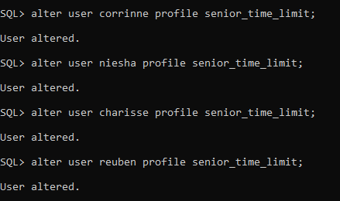

**Manager profile**

Profile assigned to senior manager

SQL> alter user michell profile manager_time_limit;

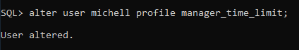

**Owner profile**

Profile assigned to senior owner

SQL> alter user edgar profile owner_time_limit;

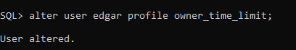

(To check profile parameter values)

SELECT * FROM DBA_PROFILES WHERE PROFILE='&PROFILE_NAME';

